H.T No
Regulations:
A18

Sreenidhi Institute of Science and Technology
(An Autonomous Institution)
Code No: 7C405 Date: 07-Oct-2021(AN)

B.Tech II-Year II- Semester External Examination, Sept/Oct-2021 (Supplementary)
ANALOG CIRCUITS (EEE, ECE and ECM)

Time: 3 Hours Max.Marks:70

Note: a) No additional answer sheets will be provided.
b) All sub-parts of a question must be answered at one place only, otherwise it will not be valued.
c) Missing data can be assumed suitably.

ANSWER ANY 5 OUT OF 8 QUESTIONS. EACH QUESTION CARRIES 14 MARKS.

Bloom's Cognitive Levels of Learning (BCLL)

Remember | L1 | Apply | L3 | Evaluate | L5
Understand | L2 | Analyze | L4 | Create | L6

 |  |  | BCLL | CO(s) | Marks
1. | a) | Distinguish Class A, B, and AB power amplifiers. | L2 | CO1 | [7M]
 | b) | What is cross over distortion in power amplifiers? Explain one suitable technique to resolve this. | L2 | CO1 | [7M]
2. | a) | Explain the operation of capacitive coupled single tuned amplifier. | L2 | CO2 | [7M]
 | b) | With suitable diagram, explain the operation of stagger tuned amplifier. | L2 | CO2 | [7M]
3. | a) | Draw and explain the operation of voltage comparator. | L2 | CO3 | [7M]
 | b) | Draw the transfer characteristics for the circuit shown in below Figure. Also draw the output waveform for a sinusoidal input amplitude of 20V. Assume ideal diodes.  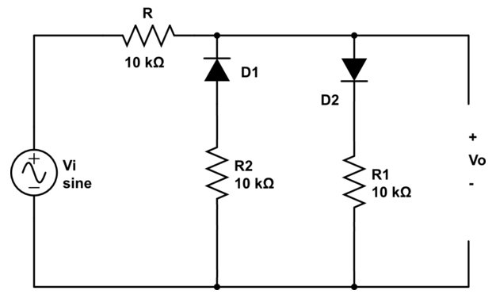 | L4 | CO3 | [7M]
4. | a) | Explain the operation of Schmitt trigger circuit. | L2 | CO4 | [7M]
 | b) | Silicon transistors with h_{FE}(min) equal to 20 are available. If V_{cc} = V_{BB} = 10V, I_{c}(sat) = 5mA, design the bistable multivibrator. Assume V_{CE}(sat) = 0.4V, V_{BE}(Sat) = 0.8V. | L3 | CO4 | [7M]
5. | a) | With suitable diagram explain the working of Boot strap time base generators. | L2 | CO5 | [7M]
 | b) | Explain the operation of a simple current sweep transistor based current time base generator. | L2 | CO5 | [7M]
6. | a) | What is pedestal in a sampling gate circuit? Explain a technique to minimize it. | L2 | CO6 | [7M]
 | b) | Draw the circuit diagram of 2-input OR gate using DTL and RTL and compare the two circuits in terms of implementation and speed. | L4 | CO6 | [7M]
7. | a) | Explain the operation of complementary symmetry power amplifiers. | L2 | CO1 | [5M]
 | b) | Compare and contrast synchronous and stagger tuning. | L2 | CO2 | [5M]
 | c) | Describe briefly about clamping circuit theorem. | L2 | CO3 | [4M]
8. | a) | For the astable multivibrator circuit shown in figure below, if R₁ = 20KΩ,  R₂ = 10KΩ, C₁ = 0.02µF, C₂ = 0.015µF, find the frequency of oscillation and duty cycle of the output waveform.  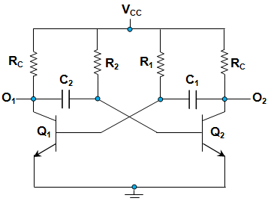 | L3 | CO4 | [5M]
 | b) | Briefly explain the operation of UJT as a sweep circuit. | L2 | CO5 | [5M]
 | c) | Describe the basic principle of bidirectional sampling gates using transistor. | L2 | CO6 | [4M]

-- 00 -- 00 –

